Potential Social Media Posts

Post #1
Story Line: Good review from the Fishbowl of Muskegon
Image for Facebook and Instagram:

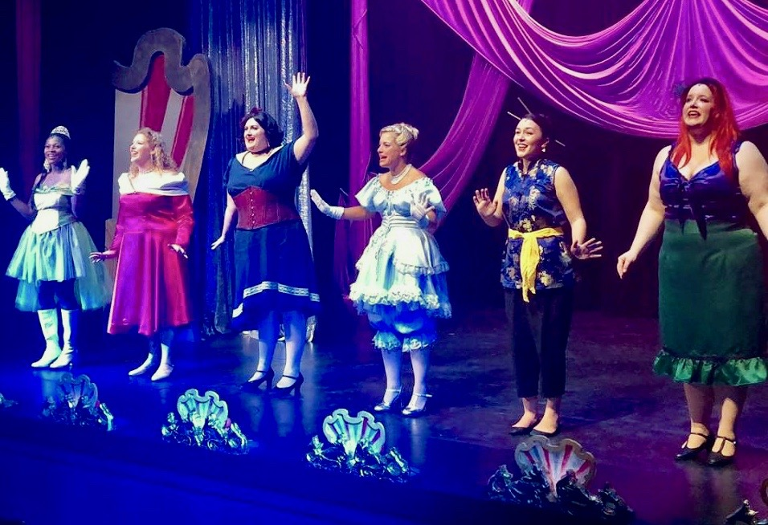

Facebook:

Link to Review at the Fishbowl, include in all three posts: https://thefishbowl.info/2018/09/15/review-fairytales-get-funny-and-feminist-in-muskegon-civic-theatre-musical-disenchanted/

Text: Rave review from local theatre critic, Bill Iddings, at the Fishbowl. “The princesses singing, swinging and declaring their feminist emancipation in Muskegon Civic Theatre’s wonderfully fun staging of the musical parody Disenchanted! are not the trilling, eye-batting, sensitive little flowers as they’ve been painted in fairytale animations. These ladies have had it with that crap”, said Iddings. Read the full review at the Fishbowl, but get your tickets because this is a show you don’t want to miss! www.muskegoncovictheatre.org

Instagram:
Text: Rave review from local theatre critic, Bill Iddings, at the Fishbowl. Read the review and get your tickets for this must-see performance. www.muskegoncovictheatre.org

Twitter:
Text: Rave review from local theatre critic, Bill Iddings, at the Fishbowl. Read the review and get your tickets for this must see-performance. www.muskegoncovictheatre.org

Post #2:
Story Line: Casting call for The Old Settler
Image for Facebook and Instagram:



Facebook:

Text: We are holding open casting calls for John Henry Redwood’s play, The Old Settler, about two sisters in 1940s Harlem dealing with middle-aged life, spinsterhood, and new love prospects. This is a delightful piece of work that closely examines life through a unique social and ethnic frame of reference.

Casting call will be Mon. and Tues., Nov. 19 & 20, 2018 at 7 PM, and callbacks Wed., Nov. 21, 2018 at 7 PM, if needed. Auditions will be held in Johnson Hall, Frauenthal Center, 427 W Western Ave., Muskegon, Michigan. Please arrive 15 minutes early for a photo and to fill out Audition Forms.

If you are interested in volunteering to assist with a non-acting role in the performance, please contact us at www.muskegoncivictheatre.org or call (231) 722-3852.

Instagram:
Text: The Old Settler casting call Nov. 19 & 20, 2018 at the Frauenthal Center. For more information, contact us at www.muskegoncivictheatre.org or call (231) 722-3852.

Twitter:
Text: The Old Settler casting call Nov. 19 & 20, 2018 at the Frauenthal Center. For more information contact us at www.muskegoncivictheatre.org or call (231) 722-3852.

Post #3:
Story Line: Upcoming Winter Theatre classes for kids 2nd to 12th Grade
Image for Facebook and Instagram:



Facebook:

Text: Do you know a child or young adult that would like to take acting classes this year? Are you looking for a different and unique gift for them? How about acting lessons! Winter semester, which goes from Jan. 5 – Feb. 9, is approaching fast. Heather McCallum, our Education Director, has a full line up of exciting classes scheduled for the upcoming semester. Classes accommodate children and teens from 2nd grade through 12th grade and cover all aspects of basic acting and theatre production. MCT classes are often taken in addition to scholastic classes at in the Muskegon school system and are an important developmental addition for young actors.
In addition to acting classes, MCT offers many electives that cover other areas of theatre production. This includes the past favorites of script writing, musicals numbers, hair & make-up, and improvisation skills. We will be expanding the electives this year to include on camera acting, prop design, and musical theatre lab.
Teens will also see some new electives coming to the line-up with the Halloween and fantasy make-up class, cosplay costume creation, and a class that specializes in the skills of auditioning for parts. These classes have been highly requested over the last two years, and we have heard the customer and look forward to providing informative and helpful instruction.
To find out about the full array of classes and electives offered and to sign up for instruction, please visit the www.musckegoncivictheatre.org website or call 231-722-3852, to speak to Heather.

Instagram:
Text: Do you know a child or young adult that would like to take acting classes this year? Are you looking for a different and unique gift for them? How about acting lessons! Winter semester, which goes from Jan. 5 – Feb. 9, is approaching fast. To find out about the full array of classes and electives offered and to sign up for instruction, please visit the www.musckegoncivictheatre.org website or call 231-722-3852 to speak to Heather.

Twitter:
Text: Are you looking for a different and unique gift for a child this year? How about acting lessons! Winter semester, which goes from Jan. 5 – Feb. 9, is approaching fast. Contact us at 231-722-3852 or www.muskegoncivictheatre.org.

